* **Video Image Processor**  
   A video image processor (VIP) system typically consists of one or more cameras, a microprocessor-based computer for digitizing and processing the imagery, and software for interpreting the images and converting them into traffic flow data.
* **Infrared Sensors**

Infrared sensors are used for signal control; volume, speed, and class measurement, as well as detecting pedestrians in crosswalks. With infrared sensors, the word detector takes on another meaning, namely the light-sensitive element that converts the reflected or emitted energy into electrical signals. Real-time signal processing is used to analyse the received signals for the presence of a vehicle.

* **Passive Infrared (PIR)**

Detection of vehicle based on emission or reflection of infrared (electromagnetic radiation of frequency 1011-1014*Hz*) radiation from vehicle surface, as compared to ambient levels emitted or reflected from the road surface. The PIR system collected following parameters: Flow volume, Vehicle presence, and detection zone occupancy. Speed with unit with multiple detection zones

* **Pulsed and Active Ultrasonic**

Ultrasonic sensors transmit pressure waves of sound energy at a frequency between 25 and 50 KHz. Pulse waveforms measure distances to the road surface and vehicle surface by detecting the portion of the transmitted energy that is reflected towards the sensor from an area defined by the transmitter’s beam width. When a distance other than that to the background road surface is measured, the sensor interprets that measurement as the presence of a vehicle The received ultrasonic energy is converted into electrical energy that is analysed by signal processing electronics that is either collocated with the transducer or placed in a roadside controller. Vehicles flow and vehicular speed can be calculated by recording the time at which the vehicle crosses each beam.

Traffic Congestion is a major issue. Because of this congestion problem, time taken for travelling will be increased. A design was developed using wireless technology with ELB-REV4 iSCADA development boards and sensors. An algorithm was also designed so that a greater number of vehicles can pass through a signal. Priorities would be given to different categories of vehicles. Emergency vehicles like ambulances, fire trucks, etc. would have top priority.

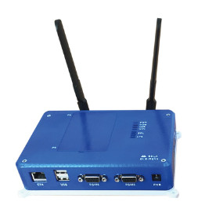

Next is given to VIP's. Next to ordinary vehicles. Priority was also given depending upon vehicle density on one side of the road. The road that has a higher vehicle volume would get highest priority. RFID is mainly used to track the objects. RFID readers and tags are used in showrooms so that no one takes off with any object or material without paying the bill. This RFID is also used to track lost vehicles. When the unique ID of RFID tags of lost vehicles are detected, then their location where they are found is obtained. The green path for emergency vehicles was also designed to provide a green signal so that the ambulance will get the right-of-way. But the disadvantage of this is all vehicles will want to start moving in that open lane, which will create even more traffic for the ambulance.

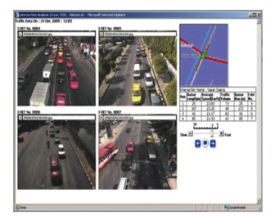

RFID SENSORS:

RFID (radio frequency identification) is a form of [wireless](https://www.techtarget.com/searchmobilecomputing/definition/wireless) communication that incorporates the use of electromagnetic or electrostatic coupling in the radio frequency portion of the electromagnetic spectrum to uniquely identify an object, animal or person.

Every RFID system consists of three components: a scanning [antenna](https://www.techtarget.com/searchmobilecomputing/definition/antenna), a [transceiver](https://www.techtarget.com/searchnetworking/definition/transceiver) and a [transponder](https://internetofthingsagenda.techtarget.com/definition/transponder). When the scanning antenna and transceiver are combined, they are referred to as an RFID reader or interrogator. There are two types of RFID readers -- fixed readers and mobile readers. The RFID reader is a network-connected device that can be portable or permanently attached. It uses radio waves to transmit signals that activate the tag. Once activated, the tag sends a wave back to the antenna, where it is translated into data.

The transponder is in the RFID tag itself. The read range for RFID tags varies based on factors including the type of tag, type of reader, RFID frequency and interference in the surrounding environment or from other RFID tags and readers. Tags that have a stronger power source also have a longer read range.